Products
We are engaged in designing, engineering, procurement, fabrication, assembly, testing and supply of a wide range of electrical and control panels that cater to multiple industrial needs. We are experts in system integration of product components from various leading technologies. Further, we also offer special purpose panels, tailored to clients’ specific needs.
Product range :
Our products range includes, but not limited the following
Control panels as per client requirement :
PLC Panels
SCADA Panels
Distributed Control Systems (DCS)
Drive Control Panels
Soft Starter Control Panels
Motor Control Centers (MCC)
Power Controls Centers (PCC)
Power Distribution Panels (PDP)
Instrumentation Panels
Control Desk Panels
Conventional Panels
Centralized SCADA Control Panel
Emergency Shutdown Systems (ESD)
Mimic Panels
- Factory Automation Products
- Smart Relay, PLC, PAC, Embedded PLC
- Text panel, HMI, Industrial PC, SCADA
- Soft Starter, VFD, Servo Systems
- Vision System, RFID/Bar Code Reader, Printers
- Proximity, capacitive, Photo, Ultrasonic, Fiber, Laser, Sensors

- All Types of Instruments
- Pressure instruments
- Flow instruments
- Level instruments
- Temperature instruments
- Analytical instruments (PH, Conductivity, Gas)
(All types in above instruments like sensors / transmitter / indicator / Switch)

- Industrial Communication
- Industrial Gateways / Convertors
- Industrial Wireless networks
- Ethernet Switches, Routers & cables
- Fiber optic accessories

- Process Control Instruments
- Timers, Counters, RPM Indicators, Process indicators
- PID, Temperature & profile Controllers. Temperature recorder, Scanners
- Energy , VAF, MFM, Power meters & energy monitor devices
- Signal isolator, Signal convertors, Voltage / Current monitoring relays
- Relay modules, TSDs, Diode modules, Cable harness,

- Electrical Switchgear items (Siemens / Schneider / C&S / Mitsubishi, L&T etc)
- MCB, MPCB, OLR, MCCB, ELMCCB ELCB, RCCB, ELR, VCB, ACB
- Relays, Pilot lamps, Push buttons, Isolators, Signaling Tower lamps
- SMPS, Surge arrestor / Protector (SPD), Terminals / Connectors
- SSR, motor Starters, Soft starters
- Junction Boxes, Enclosures, Operator Pendants, Panel AC
- Limit Switches, Sensors, Actuators, Encoders

- Cables (PVC, XLPE, Sheilded, Ethernet cables, RTD /TC cable)
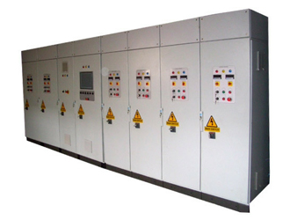
- Show gallery Add below mentioned photos
- Also Remove descriptions for All the panels
Services
We provide engineering services from design to implementation of industrial automation and control systems. We have expertise and experience on working with various technology platforms including that of Allen-Bradley, Siemens and Schneider. Further, we provide certain value services, which proved to be of key interest to our clients. Below is a key grouping of our major services :

System Design and Specification | System Engineering | Detailed Hardware Engineering
- System Performance Objectives  - Conceptual Design and System Architecture  - Site and System Specifications  - Compliance w/Local and reference Standards  - Scope Definition  - Customer/Vendor Coordination  - Optimum System Selection  - System Specifications
  Detailed Software Engineering
  - Detailed Functional Specifications
  - Network Load Calculations
  - System Parameter Configuration Details
  - Software programming
    - PLC Programming
    - SCADA, HMI Engineering
    - Networking and Data Logging
  Commissioning Engineering
  - Integration and Mechanical Completion Support
  - Cold Commissioning
  - Hot Commissioning
  - Site Acceptance Testing (SAT)
  - Operator Training and Certification
  - System Architecture Design
  - Detailed Functional Specifications
  - System Interconnection Diagrams
  - One Line Electrical Drawings
  - Power Distribution Schemes
  - System Load Calculations
  - Control Narratives
  - Loop Diagrams, Plant control Loops, Functional Body Diagrams
  - Alarms, Logics & Safety Interlocks
  System Analysis and Testing
  - Support Safety and Reliability Analyses - HAZOP/ LOPA / SIL
  - Hardware FAT
  - Software FAT with hardware integration
  Project Engineering
  - Documentation, Approvals and Reporting
  - Online and Offline Support Through Project
  - Online and Offline Support Post Commissioning
  - Panel & Cabinet Design
    - Dimension Drawings
    - Internal & External Layout Drawings
    - Cutout Drawings
    - Panel Base Layout Drawings
    - Panel Wiring Drawings
    - Bill of Materials/Take-off list
  - Procurement
  - Fabrication and Integration
  Field Engineering
  - Panel Lists
  - I/O Lists from P& ID
  - Field Instrumentation
    - Specification
    - Selection
  - Documentation
    - Location Drawings
    - Instrument Hookup Drawings
    - Junction Box Schedules & Drawings
    - Control Room Layouts
    - Cable Schedules
    - Cable Routing Drawings

Technologies
We work with various products and technology platforms from leading brands across the world. We also specialize in integration of control systems to different brands of instruments, sensors and transmitters (temperature, pressure, flow, level), analyzers, PID controllers, energy monitoring, wireless systems, RFID's, network & communication devices etc.
We have worked with an exhaustive list of technologies. Below, we list some of the key technologies our team has worked successfully with on a routine basis:
Hardware:  Allen Bradley : PLC's Micrologix, Compactlogix, Control logix, Guardlogix  HMI's Panel view- 800, Panel view Plus 7,  VFD's (Powerflex 4M, 4, 40, 400, 70, 700, 750L, 750H. 755 Powerflex  523, 525, 527),  Servo Ultra (1500, 3000), Kinetix (3, 300, 350, 2000, 5300, 5500,  5700, 6100, 6500, 7000).  Siemens : PLC's S7-200 & 200 Smart, S7-1200, S7-300, S7-400, ET200SP, ET  HMI's TP, OP, Multi panels, Basic, comfort panels,  VFD's (V20, G120, G120C, G120P, G120X G120D, G115D) ,  Servo V70, V90, S210, S120  Mitsubishi : PLC's F series, iQ-R, iQF, L, QS, Q series, HMI, GOT1000, 2000 & GS  VFD's FR-A, FR-D, FR-E, FR-F, FR-CS, FR-A800.  Delta : PLC's DVP-SS2, SA2, SX2, SV2, EX2, ES3, EC3, EH3, ES, AS, AX, AH, MC  PM, 2 Series, HMI's DOP-B series, VFD's MC-300, MH300,  MS300, VL, E, EL, ELW, L Series, Servo's ASDA-A2, ASDA-A2R,  ASDA-A3, ASDA-M, ASDA-B2, ASDA-B3 Series  Schneider : PLC's SR2/SR3, TWIDO, M100, M200. M221, M241, M251, M262,  M258, MC80, M340, M580, VFD's Altivar,  Servo's Lexium05, 15, 23, 23+, 32, 28, 53, 62 .  Others : OMRAN, Fuji,  Instrumentation : Omron, Autonics, Radix, Selec, Multispan, Rishabh, Schmershal  Sensors : Leuze, Omron, SICK, Keyence, Schneider, Autonics, Banner, Baumer  P&F, Panasonic, AB  Safety : Pilz, Schmershal, Omron, Leuze, Guardmaster | 
Software:
Allen Bradley : PLC RSlogix-500/5000, SCADA/HMI RSview-32, Factory Talk view (SE,ME), Panel builder,
Servo Ultraware, Kinetix
Siemens : PLC Microwin, TIA, Simatic Manager, SCADA/HMI WinCC
Schneider : PLC Twidosoft, Unity Pro, Unilink.
Mitsubishi : PLC GX-developer, HMI GT-designer.
Delta : PLC WPL soft, ISPsoft HMI Text editor, screen editor, DOP soft, Servo ASDA soft.

Contact us

Balaji Automation
No.5, 3rd Cross
Netajinagar, 100 feet Road
Behind Indian Bank, Near Peenya jalahalli Cross
Bangalore 560057
Tel: +91 80 28392666, 9008066215, 9481028058
balajiautoin@gmail.com
balajiautomation.om
Contct Person : Nandashankar .N

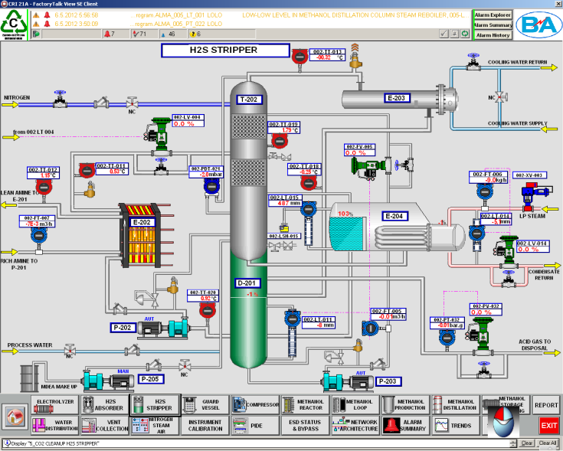
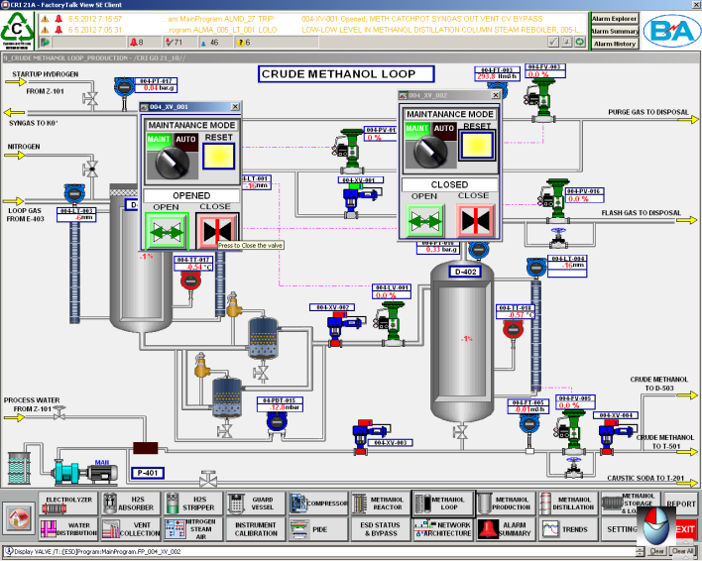

Process Automation SCADA screens
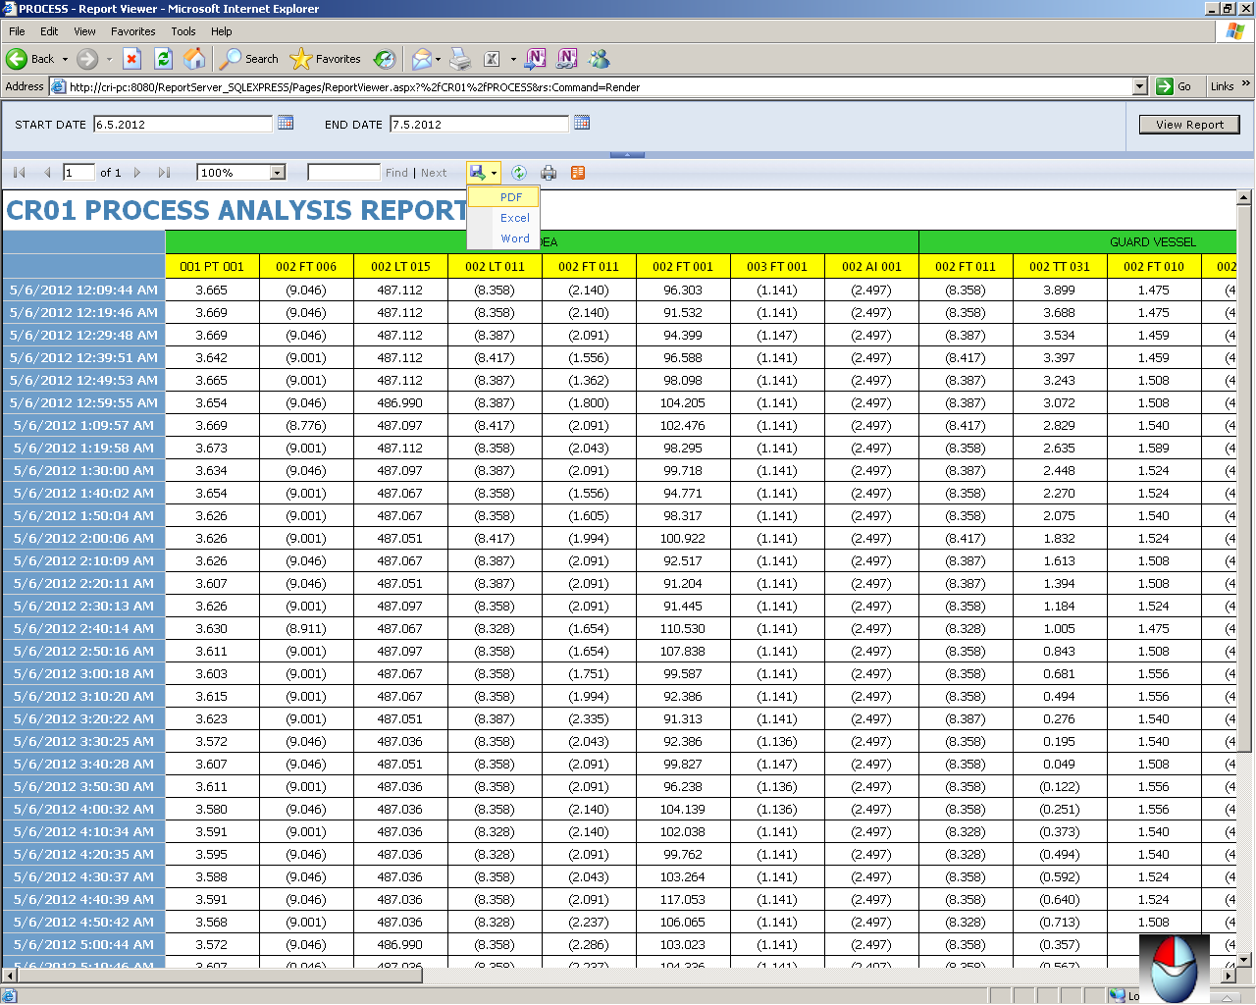

Data logging & Reporting

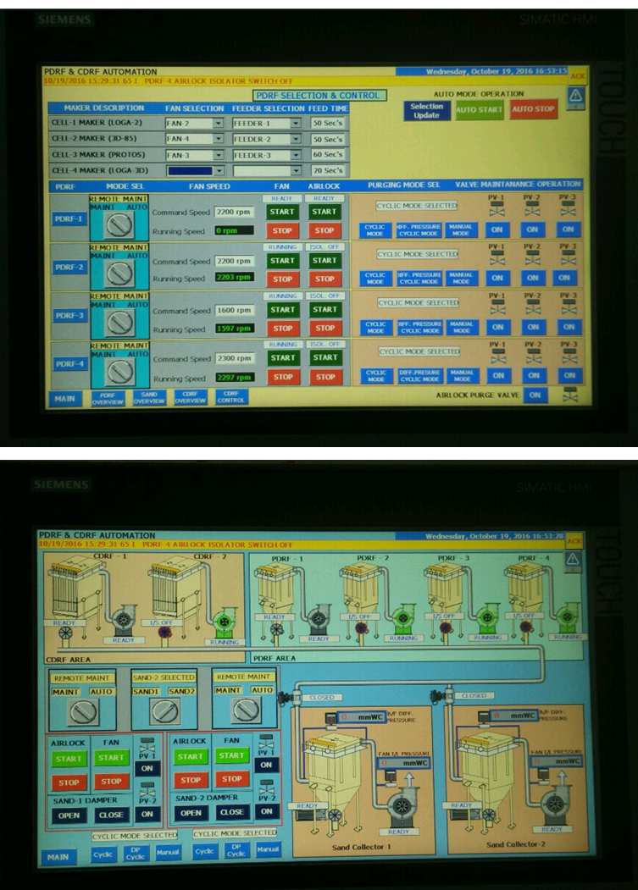

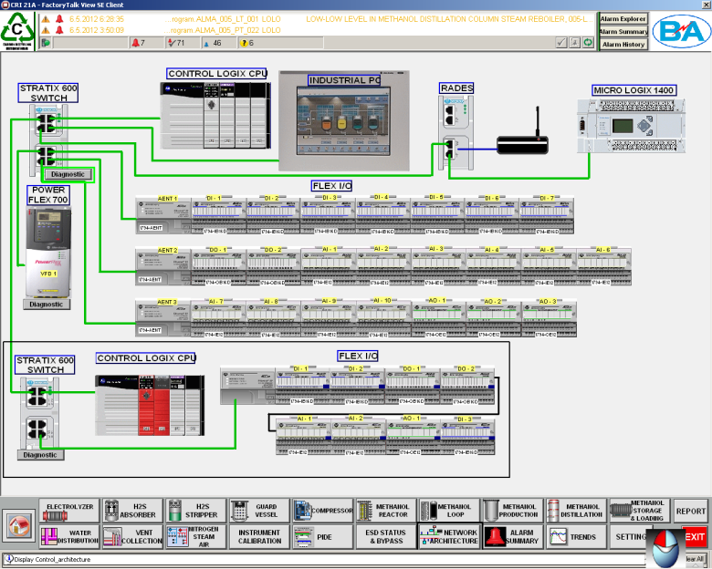
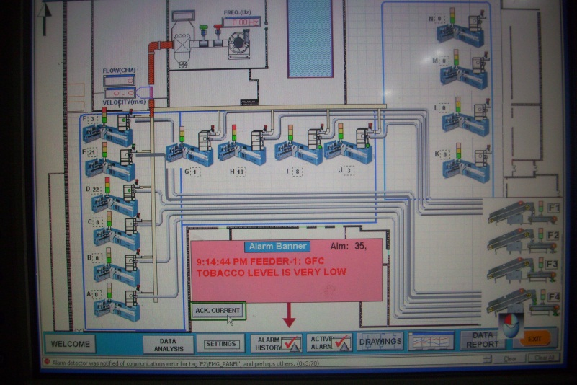
Centralised control system SCADA Screens

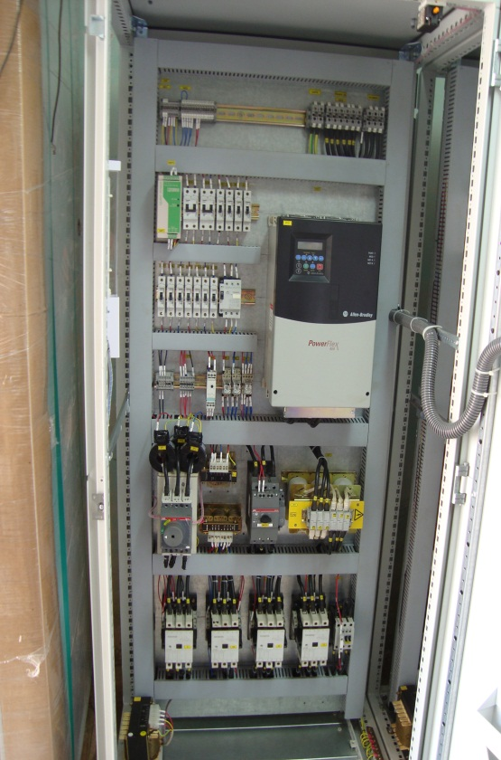
Plant automation Control Panel

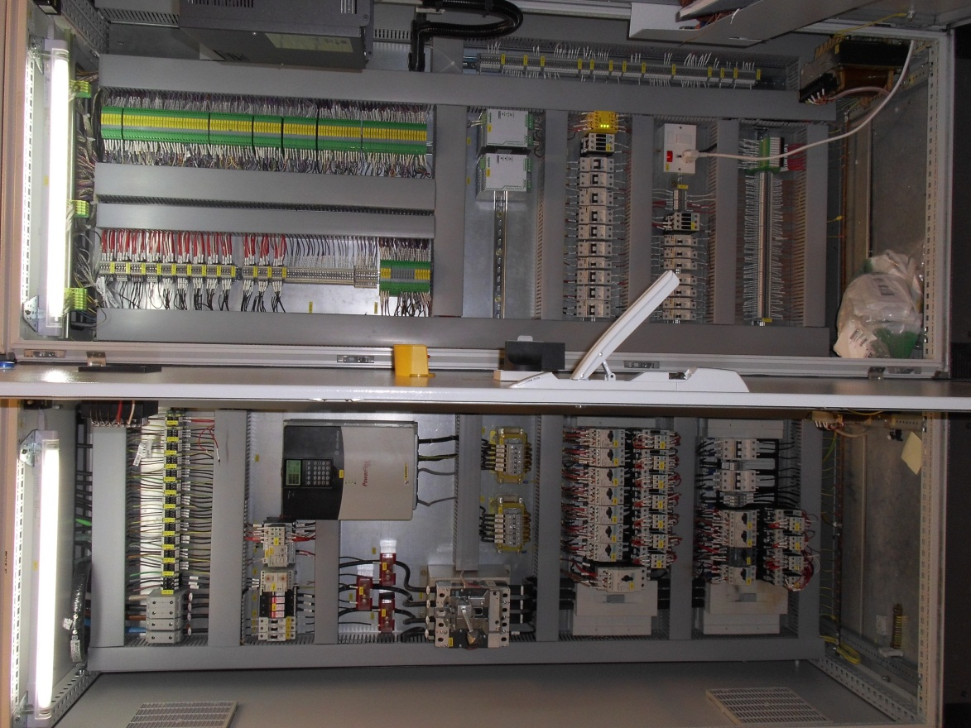
SCADA Screens

Centralized Process Automation panel

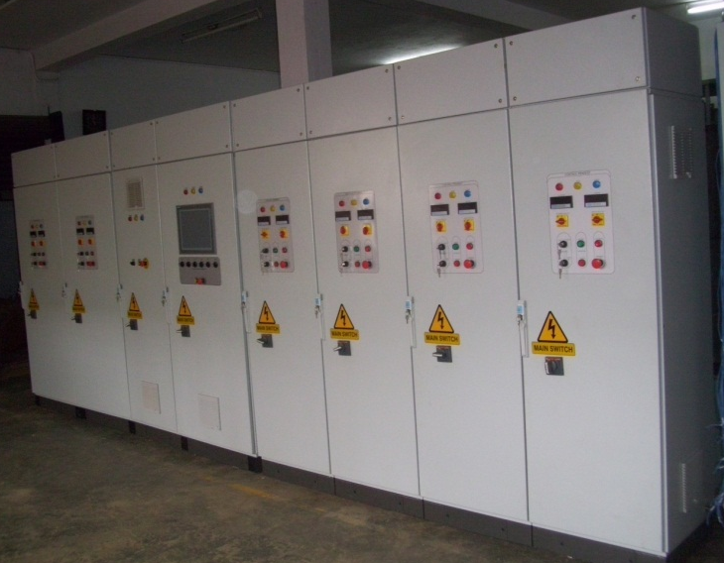
Centralised Process Control Panel

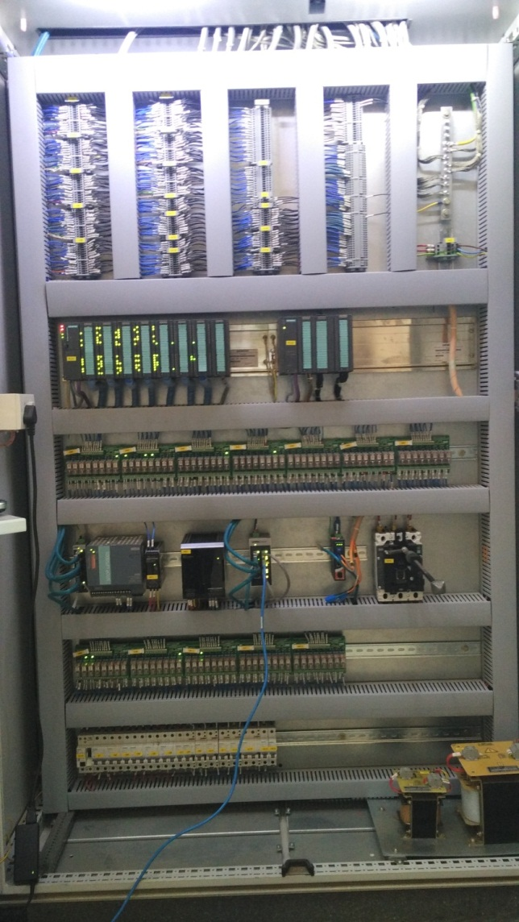
PLC Control Panels
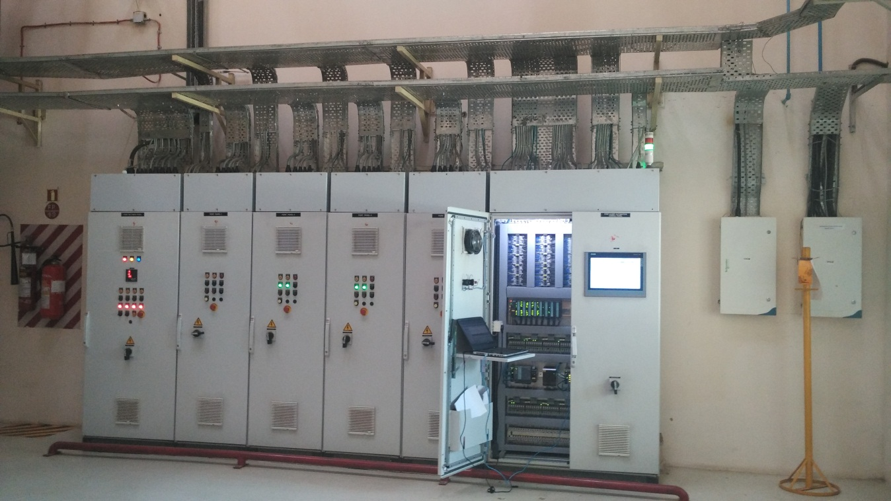

Centralised Automation Panels

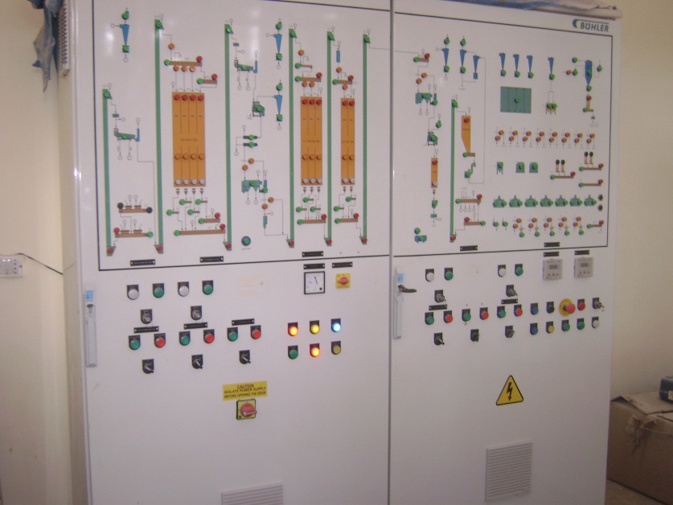
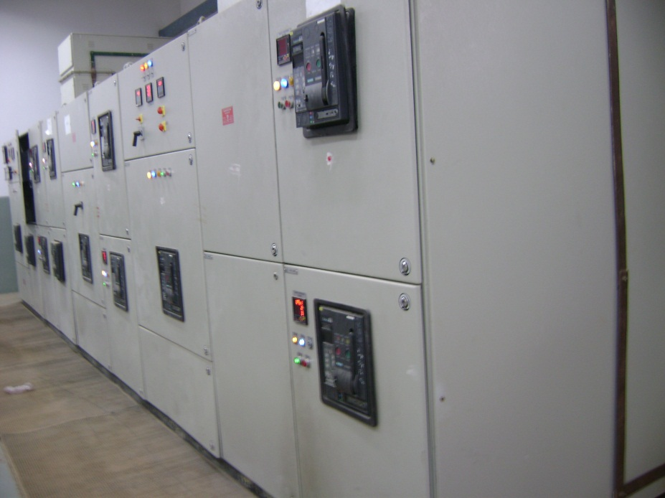
MIMIC Panel
Power distribution Panel

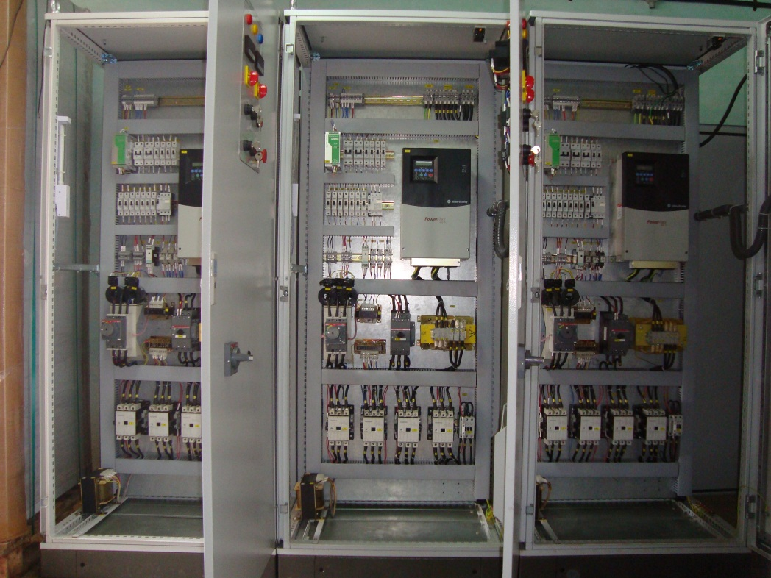
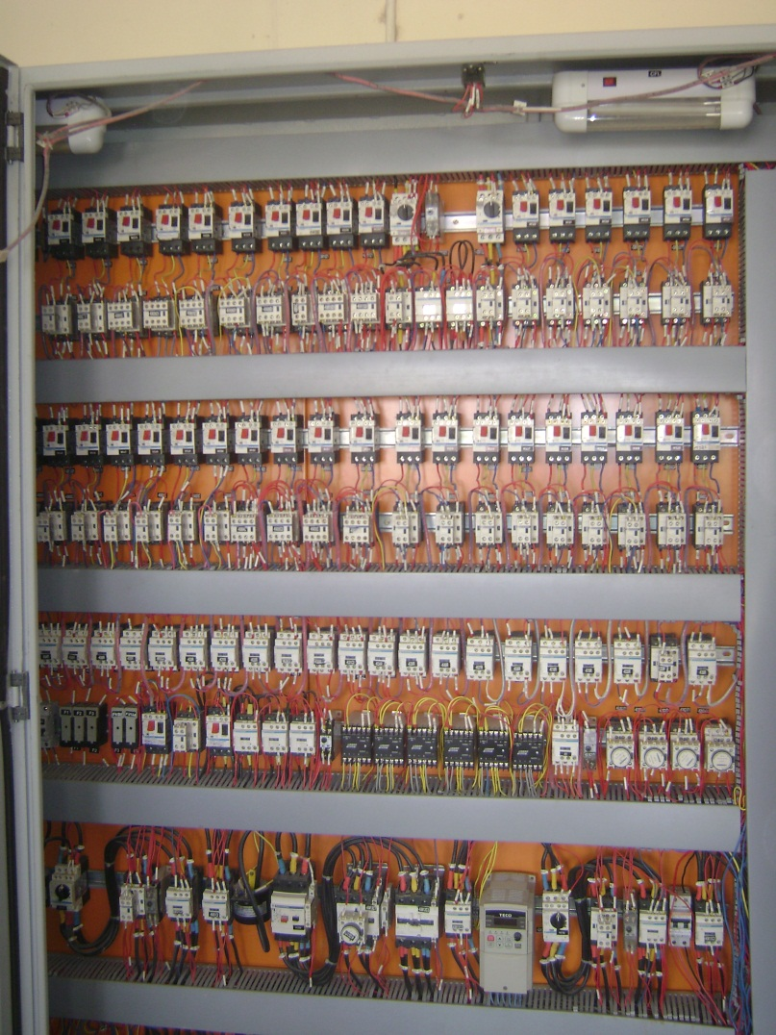
VFD Panel

Conventional MCC Panel

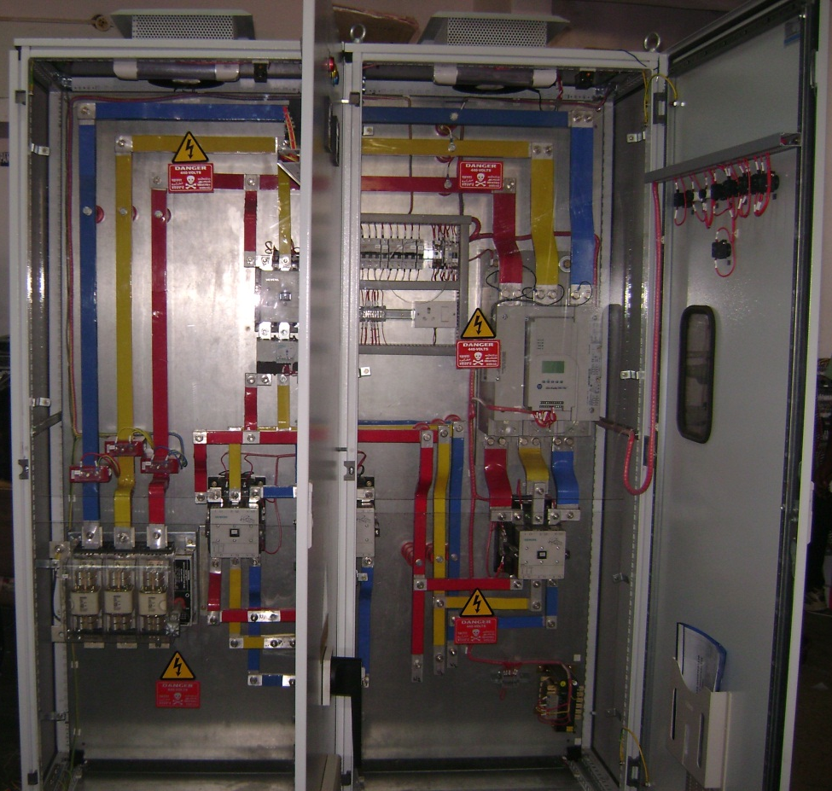
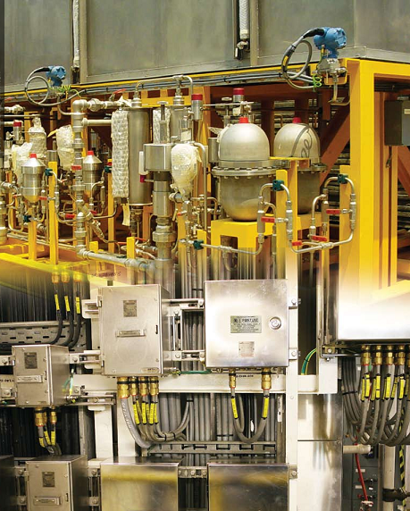
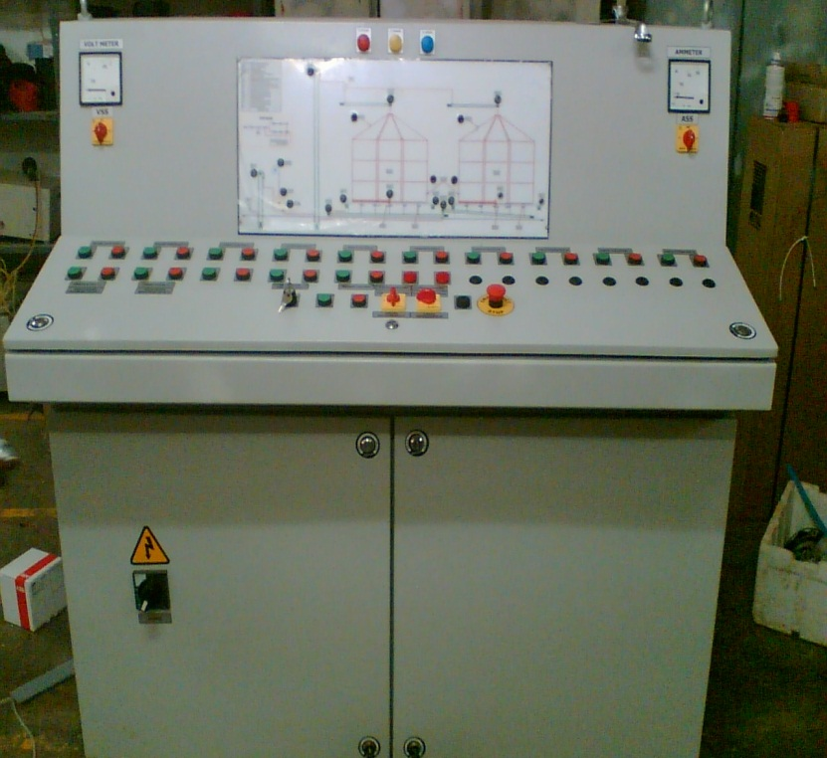

Field Wiring
Control desk Panel

Softstarter Panel
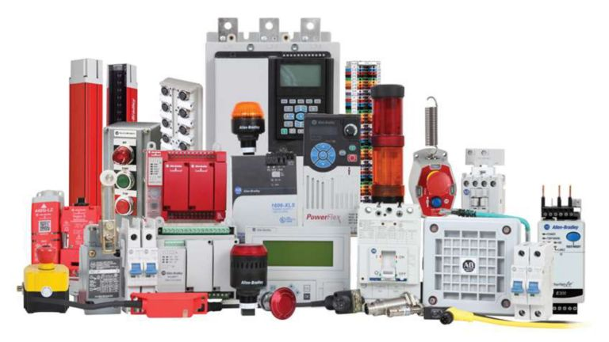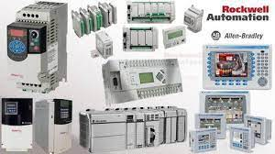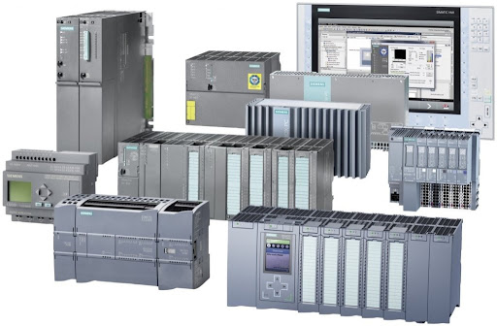
Rockwell / Allen Bradley PLC/HMI/ VFD Products
Siemens Automation Products
Rockwell / Allen Bradley switchgear Products
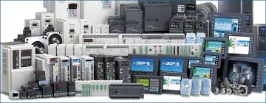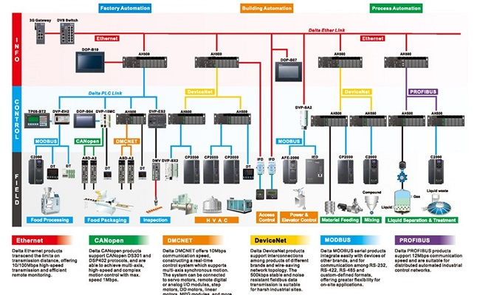
Delta Automation Products
Networks & Communications
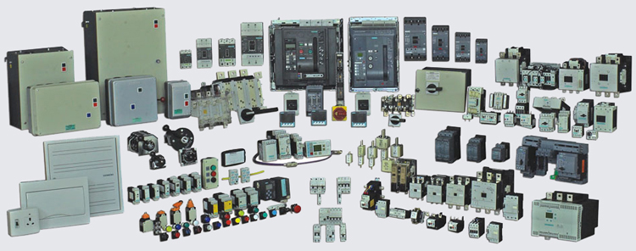
Electrical Switch gear items

